**ASSIGNMENT 1**

1.

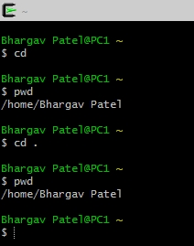

Where did that get you?

- No change in directory. As you can see above.

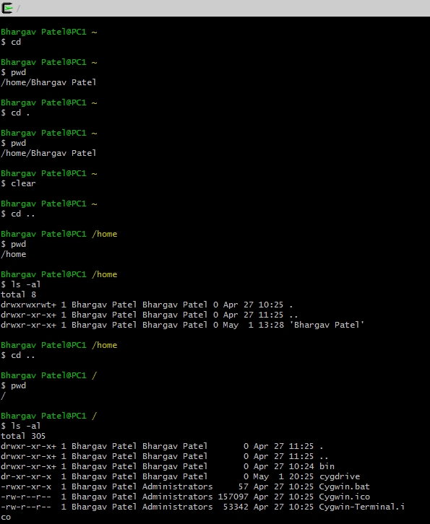

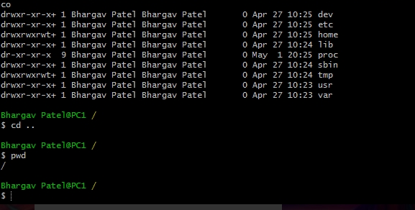

What happens now?

- this commands will shows files directories with their rights and current directory is root.

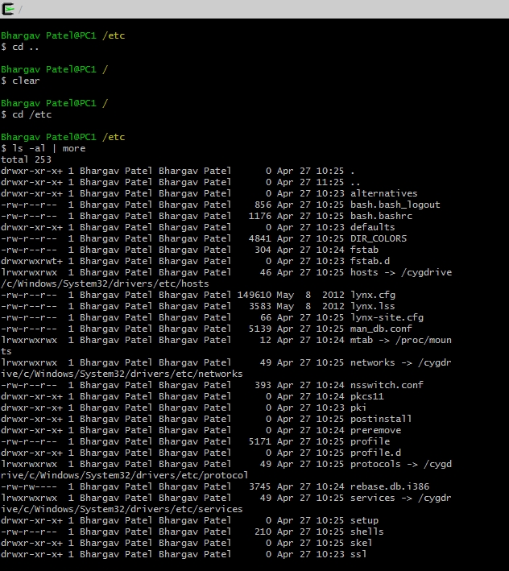

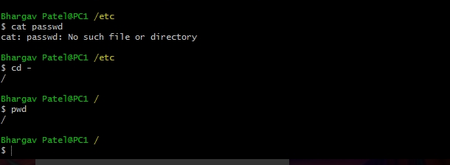

2.

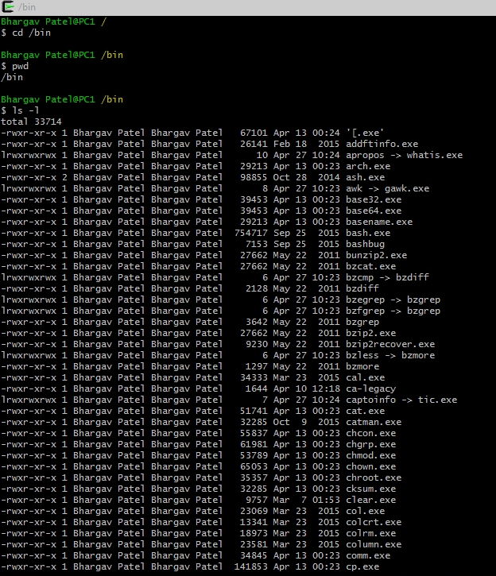

In “/bin” directory binary files were given.

3. Explore /dev. Can you identify what devices are available? Which are character-

oriented and which are block­oriented? Can you identify your tty

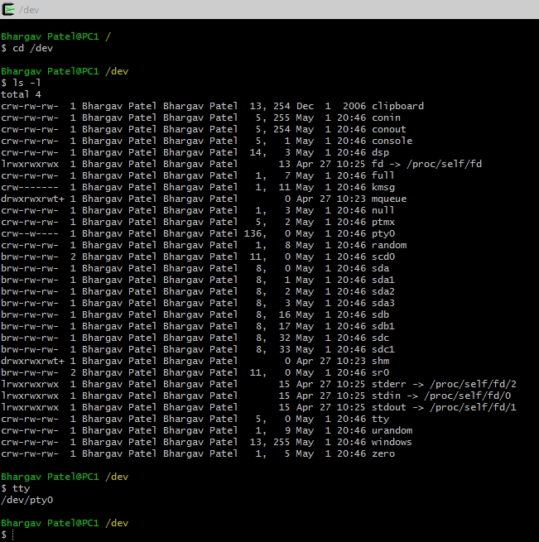

4. Explore /proc. Display the contents of the files interrupts, devices, cpuinfo,

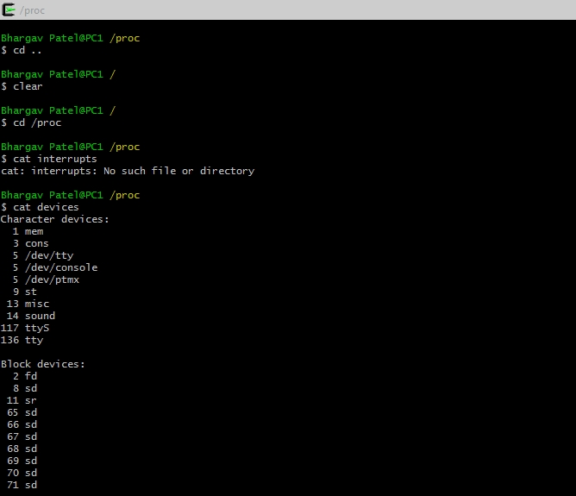

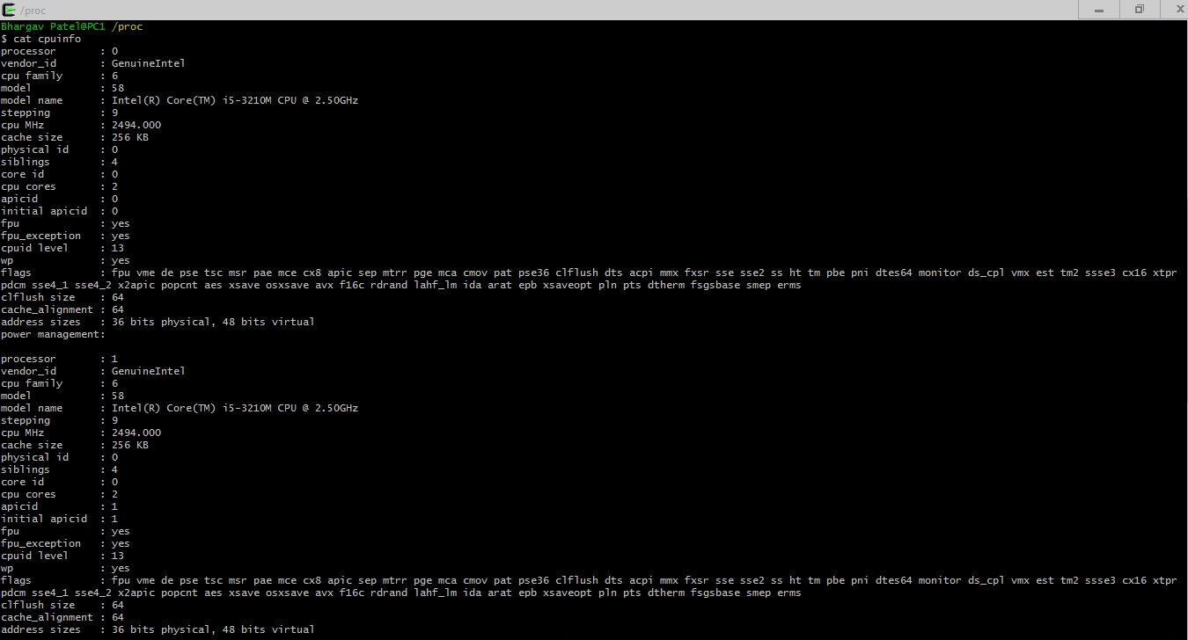

5. Change to the home directory of another user directly, using cd ~username.

6. Change back into your home directory.

7. Make subdirectories called work and play.

8. Delete the subdirectory called work.

9. Copy the file /etc/passwd into your home directory.

10. Move it into the subdirectory play.

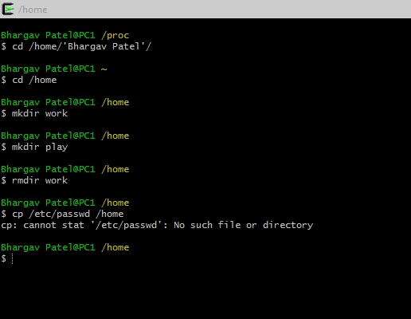

passwd file is not exist so to move that file is not possible.

But command can apply is “mv passwd /home/play”.

11. Change into subdirectory play and create a symbolic link called terminal that

points to your tty device. What happens if you try to make a hard link to the tty

device?

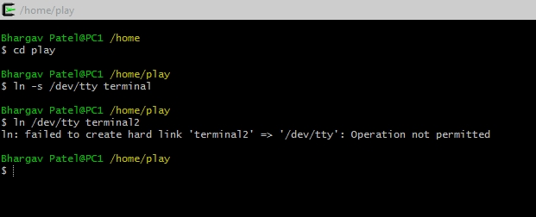

12. What is the difference between listing the contents of directory play with ls ­l and ls –L?

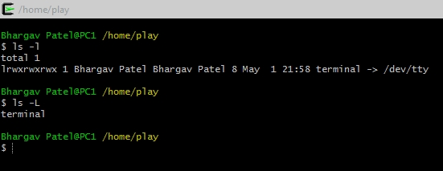

ls -l will give full descriptive details of files or directory but ls -L will give information about only file name or directory.

13. Create a file called hello.txt that contains the words “hello world”. Can you use ”cp” using

“terminal” as the source file to achieve the same effect?

- No I can’t use cp on softlink called “terminal” as source file because it is points to only just file or it is just a short cut to file that contains word.

14. Copy hello.txt to terminal. What happens?

- It will shows error message because the content of file cannot copy to softlink “terminal”

15. Imagine you were working on a system and someone accidentally deleted the ls

command (/bin/ls). How could you get a list of the files in the current directory?

Try it.

- echo * is command to display file and directory list

16. How would you create and then delete a file called “$SHELL”? Try it.

- to create a file command is:

touch \$SHELL

- to remove a file command is:

rm \$SHELL

17. How would you create and then delete a file that begins with the symbol #? Try it.

- to create a file command is:

touch \#SHELL

- to remove a file command is:

rm \#SHELL

18. How would you create and then delete a file that begins with the symbol ­? Try

it.

- to create a file command is:

touch \-?SHELL

- to remove a file command is:

rm \-?SHELL

19. What is the output of the command: echo {con,pre}{sent,fer}{s,ed}?

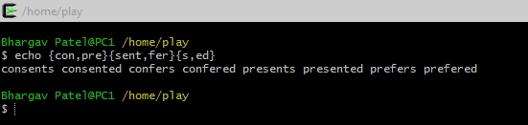

20. Still in your home directory, copy the entire directory play to a directory called

work, preserving the symbolic link.

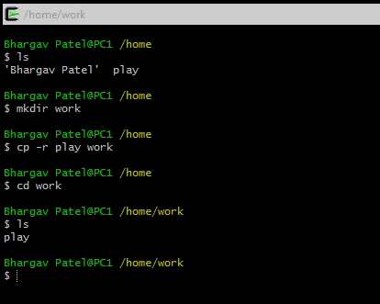

21. Delete the work directory and its contents with one command.

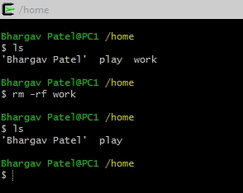

22. Change into a directory that does not belong to you and try to delete all the

files (avoid /proc or /dev, just in case!)

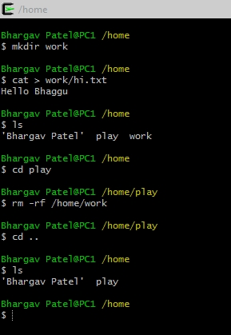

23. Experiment with the options on the ls command. What do the d, i, R and F

options do?

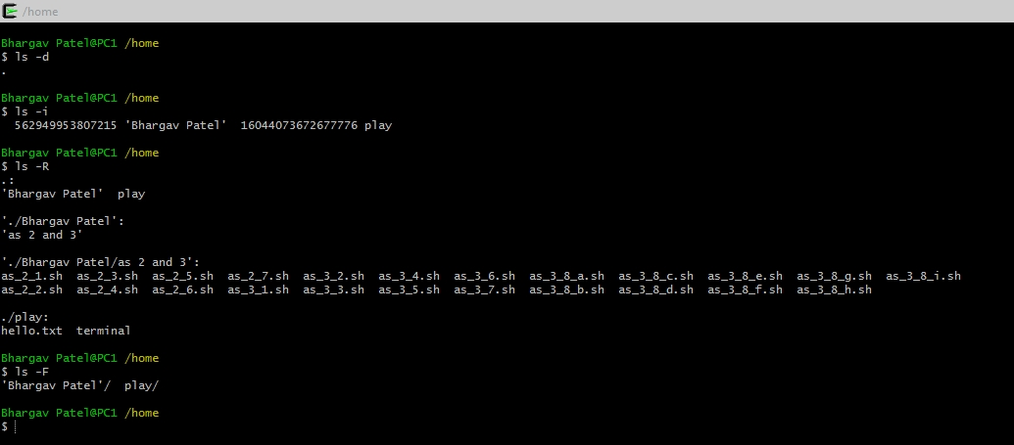

**-d**, **--directory** list directory entries instead of contents, and do not dereference symbolic links

**-i**, **--inode** print the index number of each file

**-R**, **--recursive** list subdirectories recursively

**-F**, **--classify** append indicator (one of */=>@|) to entries